1. Introduction - Briefly introduce the problem and its economic relevance. State your
research questions and objectives. Outline the structure of the report.
- How do electricity markets work today?

- Why is forecasting electricity markets difficult / what are the characteristics of electricity and electricity price determination?

- Why do we care about forecasting electricity markets (motivation: why is this an important problem)?

2. Data Description - Provide relevant descriptive statistics for selected variables in the dataset that you consider particularly relevant for the analysis. What are the main features of the different time series, such as volatility and price span, periodicity, seasonality, etc.? Explain key variables, transformations, and any data cleaning steps. Highlight with appropriate graphs and tables.
- What are the unique features of variables, including the target (electricity), for electricity price forecasting?
- It seems that there is a regime shift - have these descriptive statistics changed over the course of these regime shifts

3. Methodology - Clearly explain the econometric model(s) applied. Justify the choice of estimation and forecasting techniques. Discuss any assumptions and potential econometric issues.
- Need to predict both Xs and Ys
- Parametric SARIMAX benchmark
- LSTM NNs that have a long term trend modelling process and short term memory process driving a lot of the specific seasonalities for hourly forecasts
- STGNNs to deal with the cross border flow issues
- A model average ensemble to exploit the benefits across models
- Are there any constraints / inductive biases we can impose on our models that are motivated by an intuitive/economic/theoretical principle that will improve the performance of our model?

4. Empirical Results - Present key estimation and forecasting results in tables and figures and conduct appropriate interpretations. Perform robustness checks and discuss potential limitations.
- Look at performance of each model and see if it works particularly well for any specific hourly period
- Change data to post 2022 only for training to see how it changes forecast
- Compare to the benchmark and model average ensemble

5. Discussion and Economic Interpretation - Relate and interpret your findings for real-world implications and refer where relevant to economic theory including implications for electricity trading over various horizons. Discuss any policy recommendations or business implications if relevant.
- Use PDPs and SHAP values - sanity check that each variable inputs into the forecast in a way in line with our expectations and understand the key drivers of the price
- How does using a different variable subset or different feature-engineered space change the forecast potentially?

6. Conclusion - Summarize key findings concisely and implications. Highlight limitations and potential extensions for future research.

7. References - List all academic papers, datasets, and other sources cited in a consistent format. If using ChatGPT or similar as a reference source, make the appropriate reference and possibly with quotation marks.

8. Statement about the use of hardware and software - There are no restrictions on the use of hardware or software. However, use of cloud computing resources are not permitted. The report should include a statement about all the computing software that has been used to work with the Case. Note particular guidelines about using ChatGPT and other AI tools.

9. Statement about use of ChatGPT - Compulsory: In your report, your reference list should include a statement explaining exactly how ChatGPT and other AI tools have been used in working with your report. If the statement is absent, the report will be withdrawn from assessment. See also section 3 below.

10. Appendix (if necessary) - Include additional tables, robustness tests, or technical derivations that support the main text.

Electricity price forecasting for DK1: what the literature says about variables that matter
Wind power, cross-border flows to Germany, and lagged prices consistently emerge as the three most important predictors for DK1 day-ahead electricity prices across modern econometric and machine learning studies. The literature is surprisingly thin on DK1-specific application papers—perhaps a dozen directly study West Denmark—but a broader set of Nordic-wide and European cross-market studies provides robust evidence on which input features drive forecast accuracy in wind-dominated, highly interconnected bidding zones like DK1. This report synthesizes over 30 relevant papers published from 2018 onward, organized by market scope, with detailed attention to feature importance findings.

Papers that directly study DK1 day-ahead prices
The most informative DK1-specific paper for feature importance is Liu, Shen, Tang & Liu (2023), "Day-Ahead Electricity Price Probabilistic Forecasting Based on SHAP Feature Selection and LSTNet Quantile Regression," published in Energies, 16(13), 5152. This study applies SHAP (SHapley Additive exPlanations) to a high-dimensional feature set for DK1 hourly day-ahead prices using data from energidataservice.dk (May–August 2019). The LSTNet architecture with quantile regression is used for probabilistic forecasting.
The SHAP rankings reveal a nuanced picture. DK2 price lagged 7 days ranks as the single most influential feature—reflecting strong weekly autocorrelation across the Great Belt. German day-ahead price (DE_1) ranks fourth overall but is the most important foreign-market signal. Among renewables, hydropower production outranks wind and solar, likely capturing the hydro-thermal dispatch dynamic transmitted from Norway and Sweden. Wind power (Wind_1) ranks next, followed by solar. Among cross-border exchange features, DK1↔Germany flow (ExGE_1) dominates, followed by DK1↔DK2 and DK1↔Norway. A threshold effect emerges at approximately 800 MW on the DK1–Germany interconnector: below this level, higher exchange increases DK1 prices; above it, the relationship reverses. DOI: 10.3390/en16135152.
Becker & Blatt (2020), "High-Resolution Electricity Spot Price Forecast for the Danish Power Market," Sustainability, 12(10), 4267, takes an OLS general-to-specific approach on DK1 hourly data from 2014–2015. They find wind power production, thermal power production, and the spot price from the same month one year earlier are the most consistently significant predictors across all months. Transmission line capacities from Norway→DK1 and Sweden→DK1 are significant in winter months; DK1→Germany capacity matters in spring. The paper emphasizes that DK1's 49% wind penetration makes it a testbed for future high-renewable markets. DOI: 10.3390/su12104267.
Karabiber & Xydis (2019), "Electricity Price Forecasting in the Danish Day-Ahead Market Using the TBATS, ANN and ARIMA Methods," Energies, 12(5), 928, benchmarks ARIMA, TBATS, and ANN on DK1 data from 2016–2017. A notable finding: excluding temperature from the exogenous variable set improved forecast accuracy, suggesting temperature's effect on DK1 prices is already captured through load and wind patterns. Wind energy is confirmed as having an "important effect" on prices. Forecast combination by simple averaging of ARIMA, TBATS, and ANN further improved accuracy. DOI: 10.3390/en12050928.
Kılıç, Nielsen & Thibbotuwawa (2024), "Intraday Electricity Price Forecasting via LSTM and Trading Strategy for the Power Market: A Case Study of the West Denmark DK1 Grid Region," Energies, 17(12), 2909, applies LSTM to DK1 intraday prices using five inputs: solar production, wind production, total consumption, intraday price, and day-ahead price. LSTM outperforms benchmark ML algorithms. The authors note the limited feature set and suggest adding hydroelectric, nuclear, coal production, and energy storage data. DOI: 10.3390/en17122909.
Lucic & Xydis (2023/2025), "Performance of the autoregressive integrated moving average model with exogenous variables statistical model on the intraday market for the Denmark-West bidding area," Energy and Environment, 36(4), 1714–1750, from Aarhus University, applies ARIMAX to DK1 intraday VWAP prices (2019–2020). The day-ahead price is the key exogenous variable, achieving an average MAPE of just 1.5% for up to 24-hour-ahead intraday predictions.
The foundational DK1 paper remains Jónsson, Pinson, Nielsen & Madsen (2013), "Forecasting Electricity Spot Prices Accounting for Wind Power Predictions," IEEE Transactions on Sustainable Energy, 4(1), 210–218. Using a two-step methodology (nonparametric time-varying regression for the nonlinear wind-price relationship, then ARMA/Holt-Winters for residuals), they demonstrate that explicitly modeling the complex, nonlinear influence of wind power predictions significantly improves DK1 day-ahead forecasts. They note hydro reservoir levels vary too slowly for hourly resolution and are captured implicitly through price drift. DOI: 10.1109/TSTE.2012.2212731.

Nordic-wide studies that include DK1 in their datasets
Li & Becker (2021), "Day-ahead electricity price prediction applying hybrid models of LSTM-based deep learning methods and feature selection algorithms under consideration of market coupling," Energy, 237, 121718, is the most comprehensive Nordic feature-importance study. Using 62 features across 6 integrated markets—all Nordic bidding zones plus Germany, Netherlands, Poland, Lithuania, Estonia, and Russia—they test five feature selection algorithms (Pearson correlation, PSO-ELM, GA-ELM, RFE-SVR, LASSO) combined with three LSTM architectures for Nord Pool system price prediction (2015–2019).
SHAP analysis yields a critical finding: the German market has the most "salient role" in Nordic price generation, driven by Germany's position as Europe's largest electricity exporter with the most interconnectors to the Nordic grid. German consumption (F35) shows asymmetric effects—overconsumption drives Nordic prices sharply upward. DK1↔Germany cross-border flow is among the most predictive features, with SHAP dependence plots showing that high flow from DK1 to Germany indicates low Nordic prices. Different feature selection methods produce divergent feature subsets, confirming that no single "best" variable set exists—the choice of selection algorithm materially affects LSTM accuracy. DOI: 10.1016/j.energy.2021.121718; arXiv: 2101.05249.
Olivares, Challu, Marcjasz, Weron & Dubrawski (2023), "Neural basis expansion analysis with exogenous variables: Forecasting electricity prices with NBEATSx," International Journal of Forecasting, 39(2), 884–900, extends N-BEATS with exogenous inputs and tests on five EPF benchmark markets including Nord Pool. NBEATSx improves accuracy by ~20% over the original N-BEATS and up to 5% over other specialized methods. The interpretable decomposition reveals the relative contributions of trend, seasonality, and exogenous effects (load and generation forecasts), confirming that electricity load and production forecasts are fundamental for accurate Nord Pool price forecasting. DOI: 10.1016/j.ijforecast.2022.03.001; arXiv: 2104.05522.
Yang, Guo, Li & Zhou (2024), "Forecasting day-ahead electricity prices with spatial dependence," International Journal of Forecasting, 40(3), 1255–1270, introduces a Spatial-Temporal Graph Neural Network (STGNN) with R-vine copula for capturing cross-zone dependencies across all Nord Pool bidding zones. DK1 and DK2 form a tightly connected subgraph within the dependence structure, linked to the broader Nordic system primarily via DK2. The spatial dependence structure mirrors physical electricity flow topology, and STGNN significantly outperforms models that ignore spatial structure.
Jiang, Pan, Dong & Wang (2024), "Probabilistic electricity price forecasting based on penalized temporal fusion transformer," Journal of Forecasting, 43(5), 1465–1491, applies a modified TFT with SCAD regularization to Nord Pool and the Polish market. LASSO expert models generate initial point forecasts; the penalized TFT then produces multi-step probabilistic forecasts. The TFT's built-in variable selection network and attention mechanism provide interpretability on which time steps and features drive predictions. DOI: 10.1002/for.3084.
Jensen, Ren & Shalaginov (2024), "Day-ahead Forecasting Electricity Spot Prices in Norway with ARIMA, XGBoost, and LSTM Models," International Journal on Advances in Systems and Measurements, 17(3&4), 127–140, covers all Norwegian zones (NO1–NO5). LSTM with multivariate inputs outperforms ARIMA and XGBoost for NO2 and NO3. XGBoost feature importance (Gain scores) is reported by zone. The 2022 energy crisis severely disrupted model performance due to extreme volatility—none of the models consistently beat a heuristic baseline across all zones during this period.

Cross-border effects and market coupling research
Mascarenhas, De Blauwe et al. (2025), "Leveraging Asynchronous Cross-border Market Data for Improved Day-Ahead Electricity Price Forecasting in European Markets," Applied Energy (also arXiv: 2507.13250), exploits the fact that some European markets close their day-ahead auctions earlier than others. Using price data from Germany-Luxembourg, Austria, and Switzerland (which have earlier gate closure times), they achieve a 22% improvement for Belgian and 9% for SE3 (Swedish) forecasts. The finding that earlier-closing neighboring market prices contain exploitable information is directly relevant to DK1, which participates in the SDAC auction alongside Germany.
Bendiksen, Løining & Lyocsa (2025), "Cross-border and cross-regional electricity transmission: Is there a price impact in south Norway?," Energy Economics (SSRN #5055018), uses non-crossing quantile regressions on NO2 hourly prices (2015–2024). A striking result: flows with the Netherlands and Denmark are only weakly associated with future NO2 prices, while flows with Great Britain (North Sea Link) and Germany (NordLink) increase price volatility in the tails of the distribution. This suggests interconnector effects are asymmetric and flow-direction-dependent.
A related NHH master's thesis on the NordLink effect (operational December 2020) finds that the 1,400 MW HVDC cable between Norway and Germany led to price convergence and transmitted the 2022 energy crisis to Norwegian prices. Wind and solar production in Germany significantly impact the NO2–DE price spread.
On volatility transmission, a 2024 Energy Economics paper on Nordic volatility spillovers using TVP-VAR finds an average total connectedness index of 52.4%—over half of future price volatility in any Nordic zone is attributable to cross-market spillovers. Sweden is the primary net volatility transmitter; Denmark bears the most significant shocks. EU ETS carbon prices show a positive link with Nordic electricity market risk.

Benchmark frameworks and methodological foundations
Lago, Marcjasz, De Schutter & Weron (2021), "Forecasting day-ahead electricity prices: A review of state-of-the-art algorithms, best practices and an open-access benchmark," Applied Energy, 293, 116983, remains the gold standard. It provides five benchmark datasets (EPEX-BE, EPEX-FR, EPEX-DE, Nord Pool, PJM), two open-source models (LEAR and DNN), and the epftoolbox Python library. The LEAR model uses LASSO regularization on an autoregressive structure with ~240 regressors: lagged prices (d−1, d−2, d−3, d−7) and two exogenous variables (forecasted load and generation) with corresponding lags. A key finding: LEAR performs surprisingly well as a simple benchmark; DNNs do not always significantly outperform it. The paper establishes best practices: use rMAE as metric, apply Diebold-Mariano tests for statistical significance, and test across multiple markets with long test periods. DOI: 10.1016/j.apenergy.2021.116983; GitHub: epftoolbox.
Ziel & Weron (2018), "Day-ahead electricity price forecasting with high-dimensional structures: Univariate vs. multivariate modeling frameworks," Energy Economics, 70, 396–420, tests 32 LASSO regression variants across 12 datasets including DK1 and DK2. Multivariate models have a slight edge overall but do not uniformly outperform univariate models. Variable selection heat maps for DK1 and DK2 show which regressors LASSO selects for each hour—providing a granular view of feature importance patterns specific to Danish zones. DOI: 10.1016/j.eneco.2017.12.016.
Maciejowska, Uniejewski & Weron (2023), "Forecasting Electricity Prices," Oxford Research Encyclopedia of Economics and Finance (arXiv: 2204.11735), is the most comprehensive recent survey. It covers point and probabilistic forecasting, variable selection, and evaluation methods across 12+ markets including DK1 and DK2. Figure 4 contains LASSO variable selection heat maps showing which regressors are most commonly selected for each hour across markets—an invaluable reference for understanding DK1-specific patterns.
Uniejewski, Marcjasz & Weron (2018), "Efficient Forecasting of Electricity Spot Prices with Expert and LASSO Models," Energies, 11(8), 2039, establishes variable selection patterns for Nord Pool system price. Price for the same hour on the previous day and one week ago are most consistently selected by LASSO. Wind generation forecasts around the same and neighboring hours are important, but only forecasts for the target day (not lagged days) have high explanatory power. Day-of-week dummies are significant. DOI: 10.3390/en11082039.

German market studies with DK1-relevant findings
Trebbien, Gorjão, Praktiknjo, Schäfer & Witthaut (2023), "Understanding Electricity Prices Beyond the Merit Order Principle Using Explainable AI," Energy and AI (arXiv: 2212.04805), applies Gradient Boosted Trees with SHAP to German day-ahead prices (2017–2020). The SHAP ranking: (1) load, (2) wind generation, (3) solar generation, (4) gas prices, (5) import-export balance, (6) generation ramps. Wind affects prices more strongly than solar. Fuel prices show strong SHAP interaction effects—gas and oil prices matter more when renewable generation is low. CO2 prices were excluded due to near-monotonic trends causing overfitting. R² reaches ~0.82 versus ~0.67 for a merit-order benchmark.
Tschora, Pierre, Plantevit & Robardet (2022), "Electricity price forecasting on the day-ahead market using machine learning," Applied Energy, 313, 118752, tests DNN, SVR, LEAR, Random Forest, and LightGBM across French, German, and Belgian markets with SHAP explainability. Gas prices became the dominant feature during the 2020–2021 period when gas-fired plants dominated price-setting. Neighboring country prices (especially Swiss prices) significantly improve forecasts—a finding underused in prior EPF literature. The French market is demand-driven; the German market is renewable-driven. DOI: 10.1016/j.apenergy.2022.118752.
A 2025 paper in Renewable and Sustainable Energy Reviews, "From day-ahead to mid and long-term horizons with econometric electricity price forecasting models," systematically extends German EPF from day-ahead to year-ahead using elastic net regression. Wind infeed (especially onshore) shows the strongest merit-order effect. Gas (TTF) and coal futures are key long-term drivers. The critical finding for weekly-and-beyond horizons: short-term regressors (wind, solar, load) cannot be accurately forecast beyond a few days, so commodity prices (gas, coal, EUA) become the dominant predictors at longer horizons.
Uniejewski & Ziel (2025), "Probabilistic Forecasts of Load, Solar and Wind for Electricity Price Forecasting," arXiv: 2501.06180, shows that using probabilistic (rather than point) forecasts of load, wind, and solar as inputs to EPF models can improve accuracy for the German market. This bridges the fundamental-input quality question raised by Maciejowska, Nitka & Weron (2021), "Enhancing load, wind and solar generation for day-ahead forecasting of electricity prices," Energy Economics, 99, 105273, which demonstrated that improving the quality of fundamental input forecasts leads to significantly better electricity price forecasts.

The role of hydro reservoirs and medium-term horizons
Weekly and medium-term EPF remains underexplored in the DK1-specific literature, but several Nordic-wide studies address this gap. Knapik (2017), a CREATES Research Paper from Aarhus University, models price jumps in Nord Pool using autoregressive ordered probit models with loads, temperature, and water reservoir level (weekly NVE data as percentage of total Nordic hydro capacity). The finding is unambiguous: incorporating reservoir levels is "crucial for price jumps forecasting."
Huisman, Michels & Westgaard (2014/2015), "Hydro Reservoir Levels and Power Price Dynamics," Journal of Energy and Development, 40(1/2), 149–187, provides the foundational insight that the influence of fuel and emission costs on Nordic electricity prices is nonlinear and moderated by hydro reservoir levels. When reservoirs are full, hydro supply is abundant and fuel prices have limited impact; when reservoirs are low, fuel costs become the dominant price driver. This interaction effect is essential for any medium-term Nordic forecasting model.
Ziel & Steinert (2018), "Probabilistic mid- and long-term electricity price forecasting," Renewable and Sustainable Energy Reviews, 94, 251–266, surveys methods for weekly-to-annual horizons and notes that the input variable set typically becomes sparser at longer horizons, with reservoir levels, fuel prices, and seasonal load patterns replacing the high-frequency fundamentals (wind, solar, hourly load) that drive day-ahead models.

Synthesized ranking of predictors for DK1 electricity prices
Across all papers reviewed, the following hierarchy of predictor importance for DK1 day-ahead prices emerges:
Rank | Variable | Evidence strength | Key sources
1 | Wind power production/forecasts | Very strong; DK1 has ~49% wind penetration | Liu et al. 2023; Becker & Blatt 2020; Jónsson et al. 2013
2 | Lagged electricity prices (24h, 168h) | Very strong; universal across all EPF studies | Uniejewski et al. 2018; Liu et al. 2023; Lago et al. 2021
3 | Cross-border flows (esp. DK1↔Germany) | Strong; Germany is the dominant coupling partner | Li & Becker 2021; Liu et al. 2023; Becker & Blatt 2020
4 | German market prices and fundamentals | Strong; "salient role" in Nordic price formation | Li & Becker 2021; Liu et al. 2023; Mascarenhas et al. 2025
5 | Load/consumption forecasts | Moderate-strong; significant but less dominant than in thermal systems | Becker & Blatt 2020; Lago et al. 2021
6 | Hydro reservoir levels (Norway/Sweden) | Strong for medium-term; weak at hourly resolution | Liu et al. 2023 (SHAP); Knapik 2017; Huisman et al. 2015
7 | Natural gas prices (TTF) | Strong post-2021; moderate pre-crisis | Tschora et al. 2022; Trebbien et al. 2023; German EPF literature
8 | Thermal generation (DK1) | Moderate; reflects marginal cost of dispatchable plants | Becker & Blatt 2020
9 | Calendar effects (hour-of-day, day-of-week) | Moderate; consistently selected by LASSO | Uniejewski et al. 2018; Lago et al. 2021
10 | CO2/EUA prices | Moderate long-term; problematic in ML (monotonic trend) | Trebbien et al. 2023; German studies
11 | Solar generation | Weak-moderate; growing but still small share in DK1 | Liu et al. 2023; Becker & Blatt 2020
12 | Temperature | Weak; excluding it improved DK1 forecasts | Karabiber & Xydis 2019

Conclusion
The DK1 electricity price forecasting literature, while not as voluminous as for German or PJM markets, yields clear and actionable insights. Wind power is the dominant fundamental driver—its nonlinear, threshold-dependent relationship with prices has been documented since Jónsson et al. (2013) and confirmed through SHAP analysis a decade later. Germany functions as DK1's most influential neighbor, with German prices, consumption, and the DK1↔Germany interconnector flow consistently ranking among the top five features. The weekly autoregressive structure of prices (particularly the 168-hour lag) provides strong baseline predictive power that no model should ignore.
Three underexploited research directions stand out. First, weekly and medium-term DK1 price forecasting remains nearly unstudied, despite its practical importance for energy trading and risk management—the sparse evidence suggests reservoir levels and commodity prices (TTF, coal, EUA) become the key drivers at these horizons, displacing wind and load. Second, the post-2021 energy crisis fundamentally reshuffled feature importance—gas prices surged from a moderate to a dominant predictor—yet most DK1-specific studies use pre-crisis data. Third, modern interpretable architectures like TFT and NBEATSx have been applied to Nord Pool system price but not yet specifically to DK1 zonal prices with full SHAP decomposition. The interaction between reservoir levels and fuel prices documented by Huisman et al. (2015)—where hydro abundance suppresses the relevance of gas and coal costs—suggests that feature importance in DK1 is inherently regime-dependent, a phenomenon that static LASSO or fixed-architecture models cannot fully capture.

Madadkhan and Ikonnikova (2024)
- Look at what drives the day- ahead electricity prices
- Germany prices prediction
- Use an ensemble ML method
- Daily dataset- use 81 explanatory variables
- 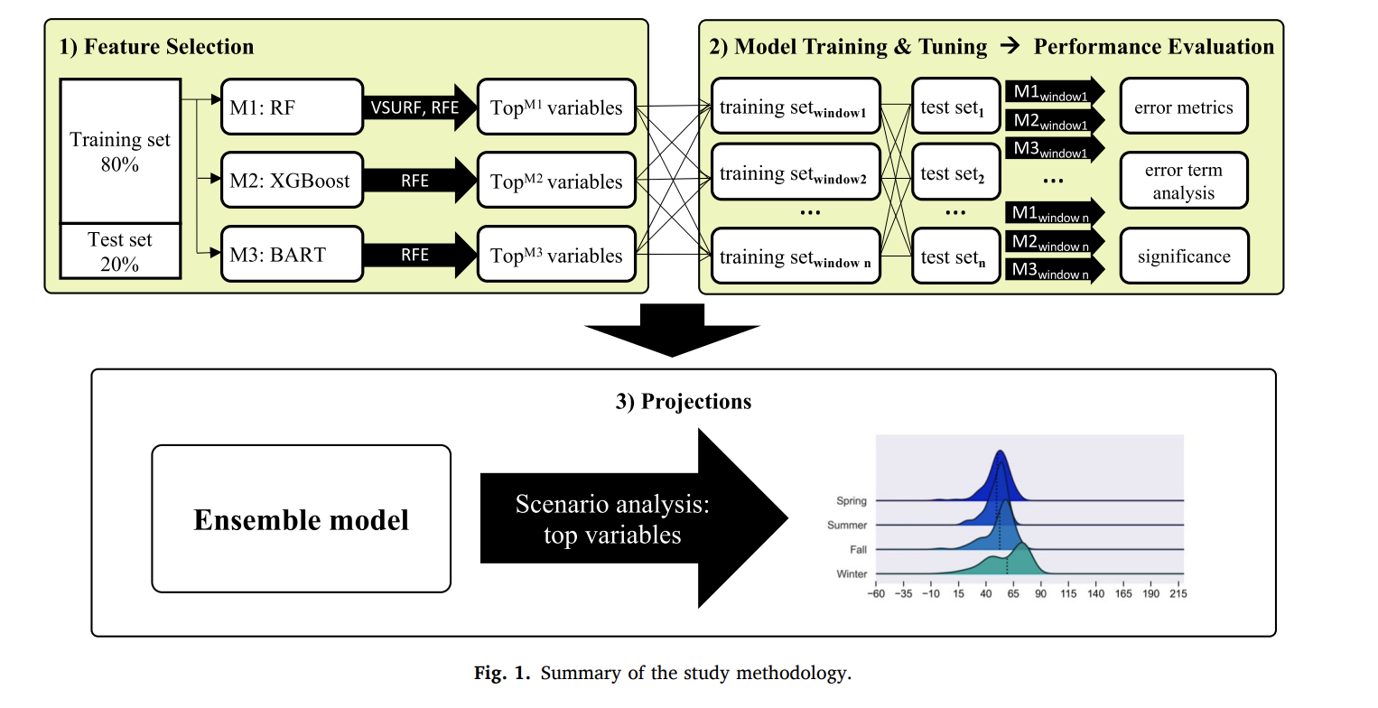
- Use RF, XGB, BART (Bayesian additive regression tree)
- SHAP values are not used- as they are unreliable under correlated features
- Feature importance is assessed via VSURF, RFE
- Use a moving and expanding window- for each test year (2016–2021), the model is trained on all preceding years and forecasts the full 365-day period without within-year recalibration
- Tests for OOS at the annual horizon
- They find that ensemble models averaging outputs of RF, XGB and BART outperform individual base models in most years
- The top predictors are
  - Carbon adjusted coal prices
  - Carbon adjusted natural gas prices
  - Forecast residual load (load not met by renewables)
  - Raw coal, natural gas and EUA carbon prices
- According to VSURF, using only 12 variables is enough to capture price dynamics
- Ensemble performance struggles in 2021- energy price shock → tree-based models cannot extrapolate beyond the range of the training data → Linear regression and LASSO outperform ML in extreme years
- They construct a clean price of fossil fuels → this is a synthetic variable
- To note: Their model fails precisely in high-price, out-of-distribution periods (2021). Since you are forecasting 2024 → a year after the 2021–2022 energy crisis → the training distribution will likely include some extreme values, potentially mitigating (though not eliminating) this extrapolation problem

Forecasting Electricity Prices
Katarzyna Maciejowska, Bartosz Uniejewski, Rafal Weron
Models used:
- Expert AR benchmark (uses expert judgement to select exogenous variables)
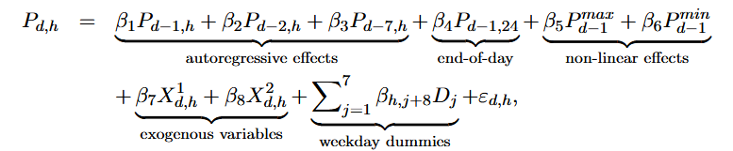
- LEAR model (AR with lasso to select variables)
- LSTM models

A Review of Electricity Price Forecasting Models in the Day-Ahead, Intra-Day, and Balancing Markets
Ciaran O’Connor Mohamed Bahloul Steven Prestwich Andrea Visentin

https://www.mdpi.com/1996-1073/12/5/928
Electricity Price Forecasting in the Danish Day-Ahead Market Using the TBATS, ANN and ARIMA Methods
- Uses ARIMA: need to have stationary and non-seasonal data first

How to decide which variable to include
- Economic intuition and existing literature
  - Excluding temperature
  - Excluding other cross border flows since only Germany seems to be relevant
  - Perhaps remove monthly variables for hourly forecasting
- LASSO based feature selection
  - But project is looking for judgement on which variables to select
- Include all variables

Making all forecasts simultaneously from a single forecast origin (Dec 31st 2023)
What claude says to do
- However, we can use calendar features for Jan 1st to Jan 7th e.g. hour of the day, day of the week, if it is a holiday, weekend/ weekday
- Train a separate model for each horizon h where each model uses only features available at the forecast origin
  - Model for h=1 (Jan 1st, 1am): trained on features known at Dec 31st to predict 1 hour ahead
  - Model for h=25 (Jan 2nd, 1am): trained on the same features to predict 25 hours ahead
  - ...and so on up to h=168
- Each model sees the same input feature vector (constructed from Dec 31st and earlier data) but is trained to predict a different horizon.

Zeil et al (2018)- https://arxiv.org/pdf/1805.06649
- What is the optimal model structure for EPF?- univariate/ multivariate
- Multivariate modelling framework does not uniformly outperform the univariate one across all 12 considered datasets
- This is indication that combining advanced structures or the corresponding forecasts from both modeling approaches can bring a further improvement in forecasting accuracy
- Multivariate modelling- with separate but possibly interdependent models for each of the 24 (48 or more) load periods
- Univariate modelling- where one large model is constructed and the same set of parameters is used to produce one- to 24-step ahead predictions for all load periods of the next day?
- Since all 24 hour prices for day d are determined at once at a single auction, there is simultaneity across the hours
- Prices for all 24 hours for the following day are disclosed at once
  - Hence, these can be seen as a multivariate time series with a 24 dimensional random vector
- Simultaneous determination means we can have only 7 models instead of 168 models

Intraday Electricity Price Forecasting via LSTM and Trading Strategy for the Power Market: A Case Study of the West Denmark DK1 Grid Region (Kilic 2024)

- Very relevant introduction and review in general for our write up
- Details the LSTM cell and how it produces forecasts
- Finds that LSTM and CNN perform better than most other models because they have an ability to capture short-term localised patterns for hourly/intra day prediction which contributes greatly to predictive performance (more so than exogenous variable inputs)
- Argues that SARIMA and statistical/parametric approaches perform well with financial variables but that given the highly non-linear and localised patterns in energy markets, these are captured better by model agnostic and data driven methods (i.e., ML and LSTM)
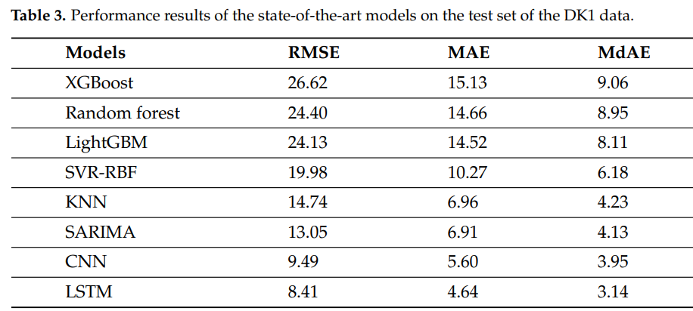
- Notes a COVID difference and reinforces this issue of regime being pertinent
- Note to us: ensembles tend to be better, maybe we could even beat these by combining CNN and LSTM predictions

Forecasting day-ahead electricity prices with spatial dependence - ScienceDirect Yang 2024

- Transforms energy price data of multiple countries and flows into a graph to use a STGNN and forms day ahead forecasts in this way

[1801.02485] Improving Short-Term Electricity Price Forecasting Using Day-Ahead LMP with ARIMA Models
- Uses various ARIMA models with and without exogenous variables - finds an ARMAX-GARCH works best

Data cleaning
- Gross flows- import and exports
- Net flows- import and exports
- Wind production- electricity from wind
- Lagged price- at 24 hours and 168 hours
- Commodity prices- natural gas and EU carbon credits
- Calendar effects
- Climate- windspeed, temperature, sunshine
- MSCIEU- missing (no values)
- Load variable
- If we don’t have hourly granularity, it is entering as a constant vector

Literature on selected variables
Liu et al (2023) ​​Liu, Shen, Tang & Liu (2023), "Day-Ahead Electricity Price Probabilistic Forecasting Based on SHAP Feature Selection and LSTNet Quantile Regression,"
- The high % of renewable energy penetration has increased the volatility of electricity generation- harder to predict prices accurately
- They do a probabilistic forecasting method based on SHAP feature selection
- Use LSTNet quantile regression
- use the SHAP method to perform feature selection in a high-dimensional input feature set
- Use the Danish electricity market
- They fore

